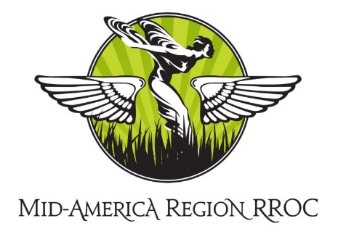

Chairman’s Message
July, 2020

Hello to all Mid America Region Members! We hope that you are well, safe, and keeping your sanity during these trying times.
We are pleased to welcome several new members to the Mid America Region! Please join us in welcoming Robert Murphy, John Powley, Christopher Smith and Gary Wells.
The heat of summer is finally upon us. We are still in the midst of the Covid 19 Pandemic and most car events have been postponed or cancelled. Some of us are beginning to join the world again- though masked and from a distance of 6 feet. Many of us have been using this time to spend with our cars and work in our garages. Jim Conley, our past MAR Regional Chairman, recently spent some time in my garage. My 1962 Silver Cloud II was the beneficiary of an oil change and everything that goes along with it. All the fluids were checked and topped off or changed as needed. I am proud to say the engine sounded great with the new oil and filter in place and no leaks were found. We had a lot of fun, masks and all! I thank Jim for his expertise and my training.
After a few years of inactivity, our Mid America Regional Website is now in the process of being updated. Marianne Spencer, MAR Treasurer, tracked down the service providers and updated the billing information and activated the website administrator role once again. David Baker, MAR Secretary, has now taken over the webmaster/administrator role and is posting updates and other information. The website address is www.rrocma.org. To view the “members only” pages you must have a username and password. Please contact David and he will set you up your user account – please send an email to dkb9323@gmail.com. Please visit the website to see what’s new.
We encourage you to share photos of and stories/information about your PMCs. In the Members Only section there is a new tab where we can post that information. To ensure your privacy, your information will only be viewable by MAR members. We also would welcome technical articles and videos; photos of recent car events; and anything interesting that has been happening in your area and garage! Please send photos in jpg format and text via email to dkb9323@gmail.com
Wendell Smith, MAR Activities Director, had some nice events planned for this summer - which had to be cancelled. He advises, however, that the All British Car Show is scheduled for Saturday, September19, 2020, at Creve Coeur Lake Park Heldman Shelter, 9AM to 3 PM. We will communicate further with you about the event. For more information, please visit this website: www.allbritishcarshow.com.
In February 2020, we created and mailed to all members our MAR newsletter, The Prairie Lady. Many thanks to Jim Schild, our newsletter editor, for his good work! We are hoping to publish another newsletter for fall/winter. The newsletter is viewable under the Members Only tab on the MAR website.
Stay well and safe and have fun with your PMC!

Craig Seekamp
Chairman – RROC Mid America Region

