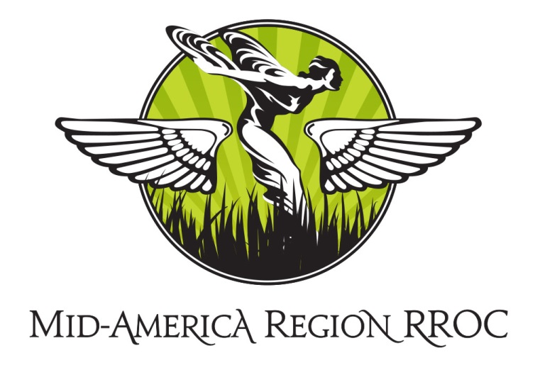
Service Clinic/
Technical Seminar

June 19, 20 & 21, 2015

The Rolls-Royce Owners Club, Mid-America Region, proudly invites you and your PMC to attend our Spring Service Clinic and Technical Seminar June 19-21 at the Hunter Engineering Classic Car Garage.

Our Seminar will be presented by renowned Ralph and Simon Curzon. You may recognize Ralph as the instructor on many of the RROC training videos. Simon is the proprietor and principle service engineer at Zenith Motors, specializing in Rolls-Royce Motor Cars.

At the Seminar, your PMC will be placed on a lift and given a service evaluation by Ralph and Simon. How long has it been since your PMC has been evaluated by Rolls-Royce experts?

Registration is $20.00 which covers coffee/pastries/refreshments and lunch on Saturday. Please RSVP early as space is limited for the clinic.

You are also invited to join members of the Mid-America Region RROC for dinner on either or both Friday and Saturday evenings. Dinner is not covered in the $20.00 registration fee.

Please RSVP to Jim Conley lrl40770c@gmail.com or by phone (636) 230-3907.

We are looking forward to seeing you and your PMC in June

Dinner and Event Schedule:

Friday, June 19, 2015

7:30PM DINNER

Cheshire Inn

Saturday, April 5, 2014

8:00am-2:30pm Spring Service Clinic

Hunter Engineering – Classics Garage

4475 Schuette Road

Bridgeton, MO 63044

(Coffee/pastries, lunch and refreshments provided)

6:00pm DINNER

Kreis’ Steak House & Bar

535 South Lindbergh Boulevard

St. Louis, MO

314 993-0735

Sunday, April 6, 2014

8:00am-11:30am Spring Service Clinic

Hunter Engineering – Classics Garage

4475 Schuette Road

Bridgeton, MO 63044
(Coffee/pastries and refreshments provided)

Accommodations: Hilton St. Louis Frontenac

1335 South Lindbergh Boulevard

St. Louis, MO 63131

314 993-8543

This hotel is conveniently located between the dinner locations, Frontenac Plaza, and an easy drive to the seminar.

RSVP: Jim, lrl40770c@gmail.com or 636 230-3907

